Niger

## GNI per capita and development level

The data set shows the GNI per capita and development level of the country each year.

## # A tibble: 19 x 5  
## country iso3c date GNIperCapita devCategory  
## <chr> <chr> <dbl> <dbl> <chr>   
## 1 Niger NER 1996 460. Low Income   
## 2 Niger NER 1998 486. Low Income   
## 3 Niger NER 2000 448. Low Income   
## 4 Niger NER 2002 473. Low Income   
## 5 Niger NER 2003 464. Low Income   
## 6 Niger NER 2004 455. Low Income   
## 7 Niger NER 2005 470. Low Income   
## 8 Niger NER 2006 479. Low Income   
## 9 Niger NER 2007 475. Low Income   
## 10 Niger NER 2008 490. Low Income   
## 11 Niger NER 2009 482. Low Income   
## 12 Niger NER 2010 503. Low Income   
## 13 Niger NER 2011 499. Low Income   
## 14 Niger NER 2012 516. Low Income   
## 15 Niger NER 2013 526. Low Income   
## 16 Niger NER 2014 542. Low Income   
## 17 Niger NER 2015 547. Low Income   
## 18 Niger NER 2016 549. Low Income   
## 19 Niger NER 2017 555. Low Income

## GDP growth and economic growth classification

The data set shows the GDP growth and the ecomic growth classification of the country each year.

## # A tibble: 19 x 5  
## country iso3c date GDPannualGrowthRate GDPgrowthCategory4  
## <chr> <chr> <dbl> <dbl> <fct>   
## 1 Niger NER 1996 0.101 slow growth   
## 2 Niger NER 1998 9.97 fast growth   
## 3 Niger NER 2000 -1.21 negative grwoth   
## 4 Niger NER 2002 4.92 moderate growth   
## 5 Niger NER 2003 2.17 slow growth   
## 6 Niger NER 2004 0.364 slow growth   
## 7 Niger NER 2005 7.33 fast growth   
## 8 Niger NER 2006 5.93 fast growth   
## 9 Niger NER 2007 3.14 moderate growth   
## 10 Niger NER 2008 7.73 fast growth   
## 11 Niger NER 2009 1.96 slow growth   
## 12 Niger NER 2010 8.58 fast growth   
## 13 Niger NER 2011 2.36 slow growth   
## 14 Niger NER 2012 10.5 fast growth   
## 15 Niger NER 2013 5.32 moderate growth   
## 16 Niger NER 2014 6.64 fast growth   
## 17 Niger NER 2015 4.39 moderate growth   
## 18 Niger NER 2016 5.71 fast growth   
## 19 Niger NER 2017 5.00 moderate growth

## Development trend

The plot shows the development trend of the country.

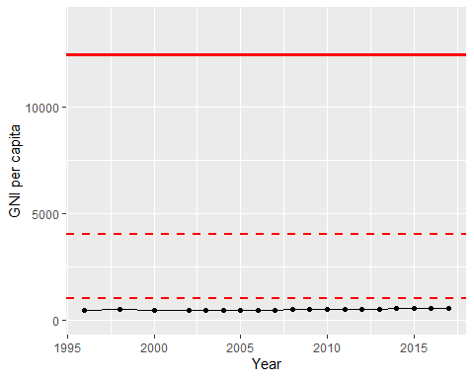

GNI Per Capita Trend